24CSI024-DATA STRUCTURES AND ALGORITHMS
UNIT 1-INTRODUCTION TO DATA STRUCTURES AND ALGORITHMS
Arrays and Array-Based Techniques (Two-Pointer, Sliding Window, Prefix Sums) LAB WORKBOOK-16.07.2026

CATEGORY: EASY

Question 1: Merging Two Sensor Logs (Two-Pointer)
Two weather stations, A and B, each recorded temperature readings independently and stored them in non-decreasing sorted order. Divya needs to merge both logs into a single sorted array for her analysis dashboard — without using any built-in sort function, and in O(N + M) time.
She uses the two-pointer merge technique:
- Initialize a pointer i at index 0 of array A and a pointer j at index 0 of array B.
- Compare A[i] and B[j]. Copy the smaller value into the output array and advance that pointer.
- Repeat until one array is exhausted.
- Copy any remaining elements of the other array directly into the output.
  - The first line of input consists of two space-separated integers N and M — the sizes of arrays A and B.
  - The second line consists of N space-separated integers (array A, sorted).
  - The third line consists of M space-separated integers (array B, sorted).
  - Print a single line of N + M space-separated integers representing the merged sorted array.
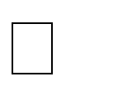

  - 1 N, M 10000



  - 104 arr[i] 104

Input 1: Input 2:

10 | 2 2  0 0  -1 4
Output: Output:

5 8 9 10 | -1 0 0 4

AIM:

To merge two sorted arrays into a single sorted array using the two-pointer technique with O(N + M) time complexity.

Pseudocode:

int i = 0, j = 0, k = 0;

while (i < n && j < m) {

if (a[i] < b[j]) {

c[k] = a[i];

i++;

}

else {

c[k] = b[j];

j++;

}

k++;

}

while (i < n) {

c[k] = a[i];

i++;

k++;

}

while (j < m) {

c[k] = b[j];

j++;

k++;

}

for (i = 0; i < n + m; i++)

print c[i];

C PROGRAM CODE:

#include <stdio.h>

int main()

{

int n, m;

scanf("%d %d", &n, &m);

int a[n], b[m], c[n + m];

for (int i = 0; i < n; i++)

scanf("%d", &a[i]);

for (int i = 0; i < m; i++)

scanf("%d", &b[i]);

int i = 0, j = 0, k = 0;

while (i < n && j < m)

{

if (a[i] < b[j])

{

c[k] = a[i];

i++;

}

else

{

c[k] = b[j];

j++;

}

k++;

}

while (i < n)

{

c[k] = a[i];

i++;

k++;

}

while (j < m)

{

c[k] = b[j];

j++;

k++;

}

for (i = 0; i < n + m; i++)

printf("%d ", c[i]);

return 0;

}

OUTPUT:

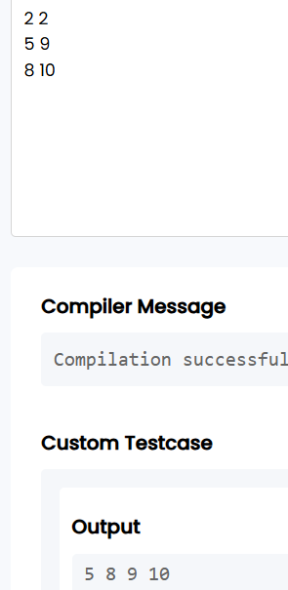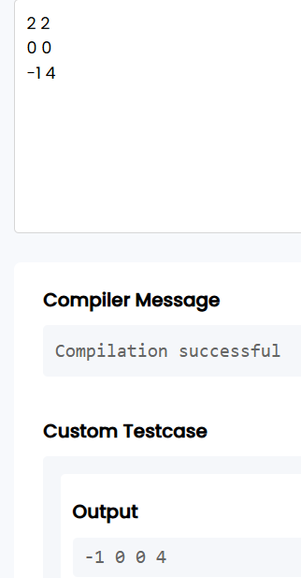

RESULT:

Thus, the two sorted sensor logs were successfully merged into a single sorted array using the two-pointer technique.

Question 2: Locating the First Below-Threshold Reading (Linear Search)
Farhan monitors battery voltage readings from a fleet of IoT sensors, logged in
the order they were received (not sorted). He needs to find the position of the first reading that drops below a safe voltage threshold T, so maintenance can pinpoint when the fault began.
  - The first line of input consists of two space-separated integers N and T.
  - The second line consists of N space-separated integers representing the voltage readings, in the order recorded.

  - Print a single integer: the 0-indexed position of the first reading strictly less than T. If no such reading exists, print -1.


  - 1 N 10000



  - 103 arr[i], T 103

Input 1: Input 2:

6 5  9 7 6 4 8 3 | 4 0  1 2 3 4
Output: Output:

3 | -1

AIM:

To find the position of the first array element that is less than a given threshold using linear search.

PSEUDOCODE:

int position = -1;

for (int i = 0; i < n; i++) {

if (arr[i] < t) {

position = i;

break;

}

}

print position;

C PROGRAM CODE:

#include <stdio.h>

int main()

{

int n, t;

scanf("%d %d", &n, &t);

int arr[n];

for (int i = 0; i < n; i++)

scanf("%d", &arr[i]);

int position = -1;

for (int i = 0; i < n; i++)

{

if (arr[i] < t)

{

position = i;

break;

}

}

printf("%d", position);

return 0;

}

OUTPUT:

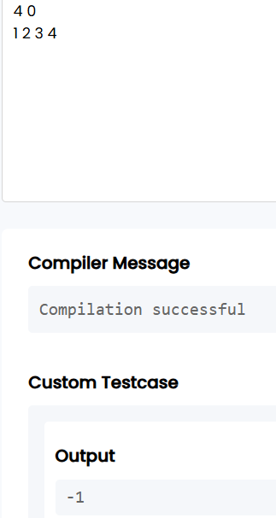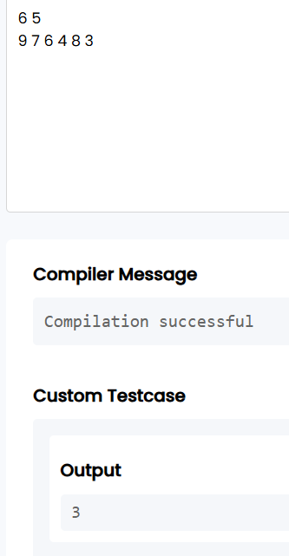

RESULT:

Thus, the first reading below the given threshold was successfully located using linear search.

CATEGORY: MEDIUM

Question 3: Maximum Rainwater Between Towers (Two-Pointer)

A telecom company has N transmission towers of varying heights standing in a row. During heavy rain, water can collect in the “well” formed between two towers, bounded by the shorter of the two. Meera wants to find the two towers that can trap the maximum volume of water between them, so she can plan drainage.

She solves it in O(N) using two pointers instead of checking every pair:

- Initialize left = 0 and right = N - 1, and maxWater = 0.

- Compute the water trapped between left and right: min(height[left], height[right]) * (right - left). Update maxWater if this is larger.

- Move the pointer at the shorter tower inward — it can never form a better pair with anything closer than the taller side already offers.

- Repeat until left meets right.
  - The first line of input consists of an integer N — the number of towers.
  - The second line consists of N space-separated non-negative integers representing tower heights.
  - Print a single integer representing the maximum water that can be trapped, in the

format: Max Water: X.


  - 2 N 10000


  - 0 height[i] 104

Input 1: Input 2:

2 5 4 8 3 7 | 4  1 1 1 1
Output: Output:

Max Water: 49 | Max Water: 3

AIM:

To find the maximum amount of water that can be contained between two towers using the two-pointer technique.

PSEUDOCODE:

int left = 0, right = n - 1;

int maxWater = 0;

while (left < right) {

int minHeight;

if (height[left] < height[right])

minHeight = height[left];

else

minHeight = height[right];

int water = minHeight * (right - left);

if (water > maxWater)

maxWater = water;

if (height[left] < height[right])

left++;

else

right--;

}

print maxWater;

C PROGRAM CODE:

#include <stdio.h>

int main()

{

int n;

scanf("%d", &n);

int height[n];

for (int i = 0; i < n; i++)

scanf("%d", &height[i]);

int left = 0;

int right = n - 1;

int maxWater = 0;

while (left < right)

{

int minHeight;

if (height[left] < height[right])

minHeight = height[left];

else

minHeight = height[right];

int water = minHeight * (right - left);

if (water > maxWater)

maxWater = water;

if (height[left] < height[right])

left++;

else

right--;

}

printf("Max Water: %d", maxWater);

return 0;

}

OUTPUT:

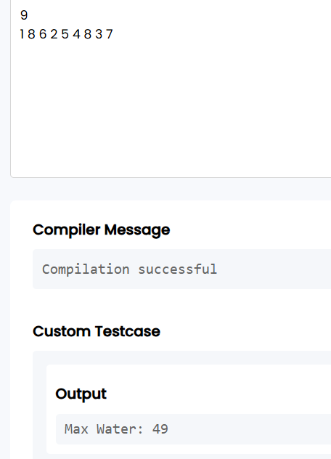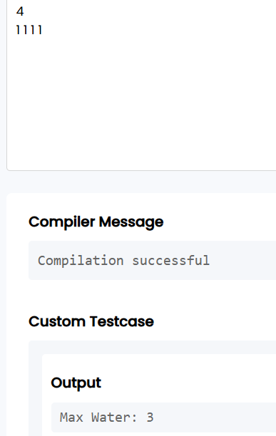

RESULT:

Thus, the maximum amount of rainwater that can be contained between the towers was successfully calculated using the two-pointer technique.

Question 4: Finding the Insertion Point for a New Calibration Value (Binary Search)

A lab keeps a sorted array of calibration reference values. Whenever a new value arrives, Ibrahim needs to find the exact index where it should be inserted to keep the array sorted — without scanning the whole array.
He uses a binary search variant that finds the first index whose value is greater than or equal to the new value:

- Initialize low = 0, high = N.
- While low < high: compute mid = low + (high - low) / 2.
- If arr[mid] < target, set low = mid + 1. Otherwise, set high = mid.
- When the loop ends, low is the correct insertion index.
  - The first line of input consists of two space-separated integers N and target.
  - The second line consists of N space-separated integers in non-decreasing order.
  - Print a single integer: the index at which target should be inserted, in the format: Insert At: X.


  - 1 N 10000



  - 104 arr[i], target 104

Input 1: Input 2:

6 | 29 |  |  |  |  | 4 | 5
10 | 20 | 30 | 40 | 50 | 60 | 1 | 2 | 3 | 4
Output: Output:

Insert At: 2 | Insert At: 4

AIM:

To find the correct position for inserting a target value in a sorted array using binary search.

PSEUDOCODE:

int low = 0, high = n;

while (low < high) {

int mid = low + (high - low) / 2;

if (arr[mid] < target)

low = mid + 1;

else

high = mid;

}

print low;

C PROGRAM CODE:

#include <stdio.h>

int main()

{

int n, target;

scanf("%d %d", &n, &target);

int arr[n];

for (int i = 0; i < n; i++)

scanf("%d", &arr[i]);

int low = 0;

int high = n;

while (low < high)

{

int mid = low + (high - low) / 2;

if (arr[mid] < target)

low = mid + 1;

else

high = mid;

}

printf("Insert At: %d", low);

return 0;

}

OUTPUT:

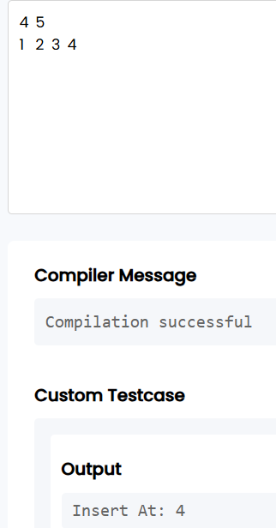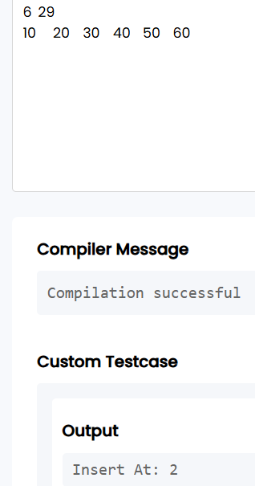

RESULT:

Thus, the correct insertion position of the target value was successfully found using binary search.

CATEGORY: HARD

Question 5: Locating a Packet in a Rotated Log Buffer (Modified Binary Search)
A circular network buffer stores log entries sorted by timestamp, but because it wraps around, the array as read out is a rotated sorted array (e.g., the oldest entries appear after the newest due to the wraparound point). Sana needs to locate a specific timestamp T in O(log N) time — a plain binary search won’t work directly since the array isn’t fully sorted end-to-end.
She adapts binary search to handle the rotation:
- Initialize low = 0, high = N - 1.
- Compute mid. If arr[mid] == target, return mid.
- Determine which half (low to mid, or mid to high) is properly sorted by comparing arr[low] and arr[mid].
- Check if target lies within the value range of the sorted half. If it does, recurse/iterate into that half; otherwise, search the other half.
- Repeat until found or the range is empty.
  - The first line of input consists of two space-separated integers N and target.

  - The second line consists of N space-separated distinct integers representing the rotated sorted array.
  - Print a single integer: the 0-indexed position of target in the array, in the format: Found At: X. If not present, print Found At: -1.


  - 1 N 10000



  - 105 arr[i], target 105
  - The array is a sorted array rotated at some unknown pivot; all elements are distinct.

Input 1: Input 2:

7 0  4 5 6 7 0 1 2 | 5 3  4 5 6 7 8
Output: Output:

Found At: 4 | Found At: -1

AIM:

To locate a target value in a rotated sorted array using modified binary search.

PESUDOCODE:

int low = 0, high = n - 1;

int position = -1;

while (low <= high) {

int mid = low + (high - low) / 2;

if (arr[mid] == target) {

position = mid;

break;

}

if (arr[low] <= arr[mid]) {

if (arr[low] <= target && target < arr[mid])

high = mid - 1;

else

low = mid + 1;

}

else {

if (arr[mid] < target && target <= arr[high])

low = mid + 1;

else

high = mid - 1;

}

}

print position;

C PROGRAM CODE:

#include <stdio.h>

int main()

{

int n, target;

scanf("%d %d", &n, &target);

int arr[n];

for (int i = 0; i < n; i++)

scanf("%d", &arr[i]);

int low = 0;

int high = n - 1;

int position = -1;

while (low <= high)

{

int mid = low + (high - low) / 2;

if (arr[mid] == target)

{

position = mid;

break;

}

if (arr[low] <= arr[mid])

{

if (arr[low] <= target && target < arr[mid])

high = mid - 1;

else

low = mid + 1;

}

else

{

if (arr[mid] < target && target <= arr[high])

low = mid + 1;

else

high = mid - 1;

}

}

printf("Found At: %d", position);

return 0;

}

OUTPUT:

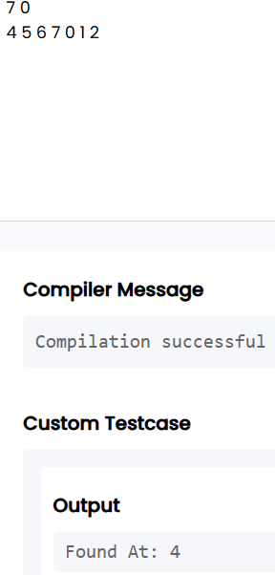

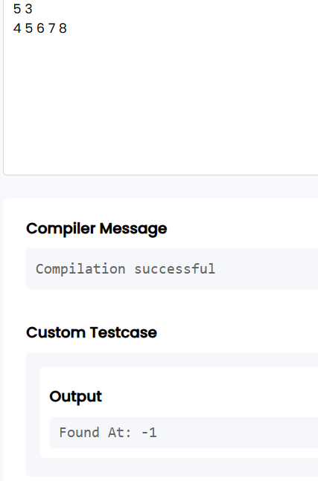

RESULT:

Thus, the target value was successfully located in the rotated sorted array using modified binary search.

VIVA QUESTIONS:
- “In binary search, why must the array be sorted before we can safely discard half the search space at each step? What breaks if it isn’t?”
Answer:
Binary search depends on the sorted order of the array. After comparing the target with the middle element, we decide whether to search the left half or the right half. If the array is not sorted, we cannot know which half contains the target, so discarding half the elements may remove the actual target.

- “Contrast the worst-case and best-case time complexity of linear search. Under what real-world circumstance would linear search actually outperform binary search on the same data?”
Answer:
The best-case time complexity of linear search is O(1) when the target is found at the first position. The worst-case time complexity is O(N) when the target is at the last position or not present.Linear search can outperform binary search when the array is small, when the target is likely to be near the beginning, or when the data is unsorted and sorting would take extra time.
- “In the rotated sorted array search problem, why can’t we simply check if arr[mid] < target the way we would in a standard binary search? What extra information do we need at each step?”
Answer:
A rotated sorted array is not completely sorted from beginning to end. Therefore, simply comparing arr[mid] with the target is not enough.We need to determine which half of the array is sorted by comparing arr[low] with arr[mid]. Then we check whether the target lies within the range of that sorted half.

- “The two-pointer merge technique for two sorted arrays runs in O(N+M) time. Why would sorting the concatenation of both arrays from scratch be a worse approach, even though both are technically valid?”
Answer:
The two-pointer technique directly uses the fact that both arrays are already sorted and completes the merge in O(N + M) time.If we concatenate both arrays and sort the complete array, the time complexity becomes O((N + M) log(N + M)). Therefore, sorting again performs unnecessary work and is less efficient.

- “In the ‘maximum rainwater between towers’ problem, why is it always safe to move the pointer at the shorter tower inward, and never the taller one?”
Answer:
The amount of water is limited by the shorter tower:
Water = Shorter Height × Distance
If we move the taller tower inward, the shorter tower still limits the water and the distance becomes smaller. Therefore, no better result can be obtained by moving the taller tower. So, we move the pointer at the shorter tower in search of a taller tower.
- “low + (high - low) / 2 is preferred over (low + high) / 2 for computing the midpoint in binary search. What specific failure does this guard against, and under what conditions would that failure actually occur in C?”
ANSWER:
The expression:
(low + high) / 2
can cause integer overflow if low and high are very large integers. The sum low + high may exceed the maximum value that an integer can store.
The expression:
low + (high - low) / 2 avoids this overflow by calculating the distance between low and high first.

- “If you were asked to implement binary search recursively instead of iteratively in C, what trade-off would you be making in terms of memory, and why does this matter for embedded systems with limited stack size?”
Answer:
Recursive binary search uses additional memory because every recursive function call is stored on the call stack.Iterative binary search uses O(1) extra space, while recursive binary search uses O(log N) stack space.This matters in embedded systems because they often have limited memory and stack space. Therefore, iterative binary search is generally safer for such systems.

- “How would you modify binary search to find the last occurrence of a repeated value in a sorted array, rather than just any occurrence?”
Answer:
When the target is found, we should store the current index as the answer and continue searching towards the right side.
if (arr[mid] == target) {
answer = mid;
low = mid + 1;
}
If arr[mid] < target, move right. Otherwise, move left.At the end, answer will contain the index of the last occurrence.

- “Explain why the two-pointer technique for merging arrays cannot be applied directly if one of the arrays is unsorted. What would need to change?”
Answer:
The two-pointer merge technique depends on both arrays being sorted. At every step, we compare the current elements and select the smaller one.If one array is unsorted, we cannot guarantee that its current element is the smallest remaining element. Therefore, the array must first be sorted, or another technique such as sorting the combined array must be used.

- “In terms of cache behavior, why might linear search on a small array sometimes run faster in practice than binary search, despite having worse asymptotic complexity?”
Answer:
Linear search accesses elements sequentially, so the data is stored and accessed continuously in memory. This provides good cache locality. Binary search jumps to different positions in the array, which may cause more cache misses. Therefore, for a small array, linear search may sometimes be faster in actual practice despite its O(N) time complexity, while binary search has O(log N) complexity.

